**Supplementary Information to Kozicka et al., 2021 and Enahoro et al., 2021**

**Appendix A – Model Integration**

To assess how the increased demand for livestock-derived food products (LDF) in low-and-middle-income countries will impact long-term on the welfare of humans and the environment, an integrated analyses framework was developed that links socio-economic trends underlying LDF demand to its associated land use management options, and potential impacts on the provision of ecosystem services. The quantitative modeling framework developed, links IMPACT, a partial equilibrium model that can project the demand for animal source foods given assumptions about growth in human populations and incomes, among other factors (Robinson et al. 2015); to CLEANED, an environmental simulation tool that includes a module that computes livestock driven land use change (Pfeifer et al. 2020); and MESH, a simulation tool that can compute the environmental services changes on land that has changed its use (Johnson et al. 2019). Figure SI.A.1 illustrates this linkage.

*Figure SI.A.1: Illustration of integrated quantitative modeling using CLEANED-R, IMPACT, and MESH*

Livestock-derived food demand

Environmental impacts

Source: Enahoro et al., 2019.

The major steps of the model integration included the following:

1. In IMPACT, the effects of changing demands for livestock-derived foods on agricultural (crops, livestock) production, supply, and trade in 2030 were simulated following alternative assumptions about socio-economic and climatic change (scenarios). Relevant IMPACT model outputs such as changes in the demand for LDF and in animal numbers needed to meet this demand, provided model inputs to parameterize the CLEANED tool.
2. CLEANED used the IMPACT results on crop and livestock production as inputs in its computation of changes in land use related to agricultural production. To do this, it employed country-specific rules for land cover changes derived from previous stakeholder consultations, historical data and literature, generating spatially explicit land cover change maps that reflected the transformation in the livestock value chains.
3. MESH took as input, the data (from CLEANED) on land use change and calculated spatially explicit measures of the supplies of selected ecosystem services. Differences in land use patterns associated with the different scenarios of livestock demand were the basis for calculating potentially diverging effects on food provision, water supply, nitrogen and phosphorus filtration, carbon sequestration and soil erosion control.

The background to the study is presented in Enahoro et al., (2019). Analyses to which the integrated modeling framework was applied are reported in Kozicka et al., (XXXX) and Enahoro et al., (XXXX). This document serves as the supplementary information to both papers. A description of the integrated models (IMPACT, CLEANED, MESH), in the context to which they have been applied in the two studies, is presented in Appendices B, C, and D following.

References for Appendix A[1]

Enahoro, D., Kozicka, M., Pfeifer, C., Jones, S., Tran, N., Chan, C. Y., Sulser, T. S., Gotor, E., & Rich, K. M. (2019). Changing Demand for Animal Source Foods and their Effects on the Provision of Ecosystem Services. *ILRI Research Brief*, *93*.

Enahoro, D., Kozicka, M., Pfeifer, C., Jones, S., Tran, N., Chan, C. Y., Sulser, T. S., Gotor, E., & Rich, K. M. (XXXX). Integrated assessment modeling of the linkages of animal-source-foods demand ro future provisioning of ecosystem services in Tanzania (in preparation).

Johnson, J. A., Jones, S. K., Wood, S. L. R., Chaplin‐Kramer, R., Hawthorne, P. L., Mulligan, M., et al. (2019). Mapping Ecosystem Services to Human Well‐being: a toolkit to support integrated landscape management for the SDGs. *Ecol. Appl.* 29. doi:10.1002/eap.1985.

Kozicka, M., Jones, S., Gotor, E., & Enahoro, D. (XXXX). Cross-scale trade-off analyiss for sustainable development - linking future demand for animal source foods and ecosystem services profvision to the SDGs (Submitted to Frontiers in Sustainable Development).

Pfeifer, C., Morris, J., Ensor, J., Ouédraogo-Koné, S., Mulatu, D.W., Wakeyo, M., 2020. Designing sustainable pathways for the livestock sector: the example of Atsbi, Ethiopia and Bama, Burkina Faso. International Journal of Agricultural Sustainability 0, 1–16. <https://doi.org/10.1080/14735903.2020.1824419>

**Appendix B – IMPACT**

The International Model for Policy Analysis of Agricultural Commodities and Trade (IMPACT) supports longer-term scenario analysis through the integration of climate (earth system), crop simulation, and water models with a core global, partial equilibrium, multimarket model to assess the potential changes in biophysical systems, socioeconomic trends, technologies and policies (Robinson et al., 2015). The multi-market component (or module) simulates the operation of national and international markets, solving for production, demand, and prices that equate supply and demand of agricultural commodities across the globe. The model includes markets (national and global) for 62 commodities, of which 39 are primary crop, 17 are processed and 6 are livestock commodities. The model includes in its quantification 159 individual countries, or regions that aggregate smaller countries (such as ‘Baltic States’ representing Estonia, Lithuania and Latvia), and 154 water basins (such as the Nile and Yangtze rivers). Intersections of the administrative regions and water basins lead to 320 distinct global food production units (FPUs) that are the basic simulation unit for agricultural production in the model. An aggregation of FPU production within a country makes up the country’s national production, which is then matched (using a set of derived demand and supply equations) to national, country-level demand. In any simulation year, a country/region is a net-exporter of any one commodity if its aggregated FPU production of that commodity exceeds the calculated national demand for it in the same year. National supply of livestock-derived food commodities sums up production from the country’s FPUs and net trade quantities from the country’s balance with international markets. A country/region is a net importer if national commodity demand exceeds the aggregated (national) FPU production of the commodity in the year. Tanzania is in IMPACT specified as the sum of three FPUs namely East African Coast (EAC), Southeast Africa (SAF) and Zambezi (ZAM), named after the key water basins. This section does not attempt to replicate the model details from the 128-page document (Robinson et al., 2015). It instead highlights material from that report that is highly relevant to the calculation of demand, supply and prices of livestock-derived food commodities (i.e., beef, lamb/mutton, pork, chicken meat, eggs and milk) and cereals used as livestock feeds in IMPACT.

*Livestock Production*

Livestock production is modeled at the FPU level and consists of two components – animal numbers, and animal yields (i.e., meat, milk or eggs) from processing of the animals. Final livestock production for each FPU and livestock commodity type is estimated as the product of the model solutions for the model’s respective animal number and animal yield equations (equations SI.B.1 to SI.B.3).

${QS}_{j,cty}=\sum_{f}{({AN}_{j,f}* {AY}_{j,f})}$ (Eqn. SI.B.1)

Where:

*QS* is national production in metric tons (MTs), *AN* is animal numbers (heads) and *AY* is animal yields (MT/head). The subscripts *j, cty,* and *f* represent activity (e.g., crop or livestock), country, and FPU, respectively.

*Animal number responds to prices as in the equation following*.

${AN}_{j,f}=\sum_{f}{({ANINT1}_{j,f}* {ANINT2}_{j,f}*\left\{{PN}_{j,cty} | {PN0}_{j,cty}\right\}* \prod_{cF}{{\left\{{PC}_{c,cty} | {PC0}_{c,cty}\right\}}^{Fε}})}$ (Eqn. SI.B.2)

Where:

*AN* is the number of animals as in equation 1. *ANINT1* and *ANINT2* are intercepts representing the initial number of animals and an exogenous rate of growth in animal herd, respectively. *PC* is consumer prices and *PN* is net price for the activity j, while *PC0* and *PN0* are their initial values. *cF* is (all) the feed commodities demanded by the livestock sector and *FƐ* is the supply elasticity for a feed commodity with respect to feed prices. The subscripts *j, f,* and *cty* are as defined for equation (SI.B..1), while *c* indicates commodity type (e.g., maize).

Animal Yield is calculated as in the equation following.

${AY}_{j,f}=\sum_{f}{({AYINT1}_{j,f}* {ANINT2}_{j,f}}$ (Eqn. SI.B.3)

Where:

*AY* is as previously defined (equation A1.1) while *AYINT1* is the initial number of animals of type *j* in FPU *f*, and *AYINT2* is an exogenous rate of growth in animal yields. Further, *AY* is indicative of growth following improved animal stocks (e.g., genetics) and management practices. It is parameterized in the model following historical trends on livestock production.

*Feed Demand*

Feed demand in IMPACT derives directly from the calculation of livestock production. It is estimated as a function of the (own) price of the livestock product, feed prices, and the exogenous trend variable representing historical growth in livestock herds. However, work has been ongoing to specify an endogenous herd growth variable that is responsive to factors such as feed quality and availability (Msangi et al., 2014). Currently, feed demand in IMPACT is estimated as consisting of two parts: a component based on livestock production and feed requirements and another (i.e., the price effect component) accounting for the potential to substitute between alternative feed sources.

Feed demand is thus specified in IMPACT as follows:

${QL}_{c,cty}=\sum_{jl}{({QS}_{jl,cty}* {Req}_{jl,c,cty})* \prod_{cF}{{\left\{{PC}_{c,cty} | {PC0}_{c,cty}\right\}}^{LFDε}}}$ (Eqn. SI.B.4)

Where:

*QL* is total feed demand for the livestock sector, *QS* is total production of each livestock activity as defined earlier (Equation A1.1). *Req* is the feed requirement of each livestock activity (*jl*) while *LFDƐ* is the elasticity of feed demand with respect to (feed) price. *PC*, *PC0*, *CF* and the subscripts *c* and *cty* are as defined in earlier equations.

*Feed Production*

Only crop-derived feed was included in the calculation of agricultural land use for livestock production, following evidence that the majority of biomass fed to livestock are not in direct competition as human food (Mottet et al.., 2017). In IMPACT, production of this feed type (e.g., cereals) occurs simultaneously as crop production for other uses, such as human food and industrial input. Total crop production is the product of crop area and crop yields. It is defined in (equation SI.B.5).

Total crop production:

${QS}_{j,cty}=\sum_{f,d}{({AR}_{j,f,d}* {CY}_{j,f,d})}$ (Eqn. SI.B.5)

Where:

Crop commodity produced is represented as *QS*, as defined previously for livestock production (Equation SI.B.1). *AR* and *CY* are the crop area and crop yield, respectively, as presented following. The subscripts *j*, *cty*, and *f* are as previously defined, while *d* represents land type and could be irrigated or rainfed.

Harvested crop area is further estimated as an area demand function.

${AR}_{j,f,d}={ARINT1}_{j,f,d}*{ARINT2}_{j,f,d}* {WF}_{f,d}^{WFε}*{\left\{{MRP}_{j,f} | {MRP0}_{j,f}\right\}}^{Aε}$ (Eqn. SI.B.6)

Where:

*AR* is total crop area for commodity *j* in FPU *f* under irrigated or rain-fed land (d). *ARINT1* is a crop area intercept denoting the initial year’s crop area while *ARINT2* is an exogenous growth rate factor. *WFƐ* is theelasticity of land demand with respect to the shadow price of land. MRP is the marginal revenue product (which is used to index prices) with *MRP0* its value in the initial model simulation year. *AƐ* is the elasticity of land demand with respect to marginal revenue product (of land). The exogenous trends informing crop area estimation derive from historical trends in land use, and expert judgement about future trends.

Crop yields respond to prices and to water and climate shocks, as in equation A1.7.

${AY}_{j,f,d}={AYINT1}_{j,f,d}*{AYINT2}_{j,f,d}* {WS}_{j,f,d}* {CS}_{j,f,d}*{\left\{{PN}_{j,cty} | {PN0}_{j,cty}\right\}}^{Yε}*{PF}^{Fε}$ (Eqn. SI.B.7)

Where:

*AY* is crop yield*, AYINT1* is the base year yield and *AYINT2* is an exogenous growth rate factor. *WS* and *CS* are water stress and climate change shocks emanating from the water and climate models in IMPACT, respectively. *PF* is input price while *YƐ* is yield supply elasticity with respect to the commodity net price, and *FƐ* is yield supply elasticity with respect to input prices.

*Commodity Demand and Supply*

Aggregate demand for a commodity sums up household food demand, agricultural intermediate demand (which includes livestock feeds), and intermediate demand from industrial (and biofuel) sectors.

${QD}_{c,cty}=\sum_{h}{\left({QH}_{c,h,cty}\right)+ {QINT}_{c,cty}+{QL}_{c,cty}+{QBF}_{c,cty}+ {QOTH}_{c,cty}}$ (Eqn. SI.B.8)

Where:

*QD*, *QH*, and *QL*, are total commodity demand, household food demand, and feed demand from livestock sector, respectively. *QINT* is intermediate demand from the ag-processing sector while *QBF* is intermediate demand for biofuel feedstock and *QOTH* covers all other demand. *H* is household type while *c* and *cty* are commodity type and country, as previously defined. Total population, per capita income, price of a commodity (i.e., own price), and prices of all other commodities (i.e., cross prices), all drive the household demand for a commodity (not shown in equation). Further, annual increases in population and per capita income (i.e., population and income growth) follow country-specific trends. These vary by global socio-economic scenario and have been derived from the shared socioeconomic pathways of the intergovernmental panel on climate change, IPCC, for use in IMPACT (Riahi et al, 2017).

*Commodity Markets*

The system of demand and supply equations in IMPACT are solved (using specialized solvers in the GAMS programming language) to find a set of domestic and world prices for which all commodities (i.e., crop, livestock and processed) clear, i.e., total demand is equal to total supply. The model adopts a closed global economy assumption, i.e., total world production equals total world demand at the end of the simulation year. As in the equation SI.B..9 below, the sum of net trade throughout the world must equal zero.

$\sum_{cty}{{NT}_{c,cty}=0}$ (Eqn. SI.B.9)

Where *NT* is net trade. Within each country, commodity trade further responds to quantities of national production, to domestic demand, and to change in stocks (see equation below).

${NT}_{c,cty}={QSUP }_{c,cty }-{QD}_{c,cty }- {QSt}_{c,cty }$ (Eqn. SI.B.10)

Where:

*QSUP* is national commodity supply consisting of production and transformation of production outputs to commodities, *QD* is the total demand from household, agricultural, industrial and other sectors (as in Equation A1.8), and *QSt* is the stock.

The key model outputs of concern in assessing impacts of dietary changes on the environment are total demand (*QD*), total production (*QS*) and net trade (*NT*) of the different agricultural commodities. These indicators also lead to the derivation of secondary indicators that can be used for additional impact assessments.

**Post-solution models**

Two major indicators derived from the primary outputs in IMPACT are relevant to a discussion about dietary changes (in Tanzania) in the future. These are population at risk of hunger, and malnutrition in children. Given the potential role of livestock-derived foods in the future supply of proteins and key essential micronutrients (Enahoro et al., 2018), the indicator of malnutrition in children under five may be most relevant.

*Malnutrition in children under five*

In IMPACT, an indicator of undernourishment in children is calculated using calorie availability from the model solution, mathematical models based on established relationships of food availability and country-specific socio-economic indicators such as access to education, and health and sanitation (Robinson et al., 2015). The statistical relationship used, which is based on Smith and Haddad (2000) is reported in Robinson et al., 2015 as follows:

${∆UN}_{t,t0}=-24.25 ln\left({KCal}_{t} | {KCal}_{t0}\right)-\left(71.76* ∆{LF}_{t, t0}\right)-\left(0.22* ∆{SCH}_{t, t0}\right)-(0.08* ∆{WAT}_{t, t0})$ (Eqn. SI.B.11)

Where:

*UN* is undernourished children (percent change from base year) and *KCal* is kilo calories (availability). *LF* is the ratio of female to male life expectancy at birth, *SCH* is female schooling rate, measured as gross female secondary school enrollment rate, and *WAT* is percent of the population with access to safe water. The symbol Δ represents the difference between time *t* and *t0*, the initial simulation year (time zero). The data used to parameterize *LF*, *SCH*, and *WAT* are national-level estimates and come from various sources reported in Robinson et al. (2015). On the other hand, *KCal* is partly generated from IMPACT, making use of the calorie count associated with the primary model solutions on commodity demand and supply. Further, the calculated value of *UN* (percent change) is applied to the population figures coming from the respective shared socioeconomic pathways of the IMPACT scenarios, to estimate total populations of children affected (by malnutrition).

References for Appendix B

Mottet, A., de Haan, C., Falcucci, A., Tempio, G., Opio, C., & Gerber, P. (2017). Livestock: On our plates or eating at our table? A new analysis of the feed/food debate. Global Food Security, 14(January 2016), 1–8. https://doi.org/10.1016/j.gfs.2017.01.001

Msangi, S., Enahoro, D., Herrero, M., Magnan, N., Havlik, P., Notenbaert, A., & Nelgen, S. (2014). Integrating livestock feeds and production systems into agricultural multi-market models: the example of IMPACT. Food Policy, 49(2), 365–377. http://www.sciencedirect.com/science/article/pii/S2211912414000133

Riahi, K., van Vuuren, D. P., Kriegler, E., Edmonds, J., O’Neill, B. C., Fujimori, S., Bauer, N., Calvin, K., Dellink, R., Fricko, O., Lutz, W., Popp, A., Cuaresma, J. C., KC, S., Leimbach, M., Jiang, L., Kram, T., Rao, S., Emmerling, J., … Tavoni, M. (2017). The Shared Socioeconomic Pathways and their energy, land use, and greenhouse gas emissions implications: An overview. Global Environmental Change, 42, 153–168. https://doi.org/http://dx.doi.org/10.1016/j.gloenvcha.2016.05.009

Robinson, S., Mason d’Croz, D., Islam, S., Sulser, T. B., Robertson, R. D., Zhu, T., Gueneau, A., Pitois, G., & Rosegrant, M. W. (2015). The International Model for Policy Analysis of Agricultural Commodities and Trade (IMPACT): Model description for version 3 (No. 1483; IFPRI Discussion Paper). http://ebrary.ifpri.org/cdm/ref/collection/p15738coll2/id/129825

**Appendix C – CLEANED-R**

*Biomass supply (land supply)*

The CLEANED tool is a spatially explicit simulation tool that computes environmental impacts, namely water use, greenhouse gas emission, biodiversity loss and nitrogen balance of a given area based on livestock production parameters that are user defined (Pfeifer et al. 2016). A full description of the tool has been presented in the supplementary information of Pfeifer et al. (2020). Material from that paper is presented here for convenience. CLEANED consists of 6 modules, namely productivity, water, greenhouse gas, biodiversity, nitrogen balance and land use change, as listed in Table SI.C.1.

Table SI.C.1: Overview of models and geographical data in the CLEANED modules

|  |  |
| --- | --- |
| **Module** | **Model used** |
| Production and land allocation | IPCC energy requirement per animal in each category  Allocates the total energy to land cover based on crop and grazing land |
| Land use change | Grazing land is converted to cropland based on suitability |
| Water | Evapotranspiration of the biomass fed to livestock |
| Greenhouse gas emissions | IPCC tier II computation |
| Biodiversity | UICN red list allocated to land cover |
| Soil nitrogen balance | Nitrogen balance (Smaling 1993) including an erosion model (RUSLE) |

The productivity module computes a measure of total demand for biomass needed as feed for a defined livestock population; and compares this with the biomass production in the area. It outputs a total production in terms of animal sourced food, meat and milk produced, as well as the area needed for this production in terms of arable land and grazing land. The model used for these computations are based mainly on IPCC tier 2 computations. The land allocation model behind the productivity module is specific to every CLEANED version.

In the water module, quantity of water needed to grow the total biomass demand is computed, considering that different feed and fodder types require different amounts of water based on evapotranspiration. Different metrics are then computed, such as the water usage per animal/milk/meat, the ratio of water over actual rainfall in the area.

The greenhouse gas computation is based on the Intergovernmental Panel on Climate Change Tier 2 calculations. It includes emission from enteric fermentation, manure management, feed and fodder production and land use change for feed and fodder.

Biodiversity measures are based on the International Union for Conservation of Nature (IUCN) red list (<https://www.iucnredlist.org>/). A species richness index is computed to show where most endangered species are located. In the case of a land use change, it also computed how many species that are critically endangered loose a piece of their habitat.

The nitrogen balance is a proxy for soil health and is computed by the difference of nitrogen inputted into the soil and that extracted. The inputted nitrogen consists of manure and fertilizer that is added to the soil, atmospheric deposition, and biological fixation. The outputted nitrogen consists of nitrogen absorbed by the feed and fodder, erosion, nitrogen leaching, and gaseous losses.

For any change in simulated agricultural or livestock production, these 5 modules can be re-computed, giving new impact metrics.

In addition, there is a land use module that converts the land to arable land based on a user-defined percentage of additional biomass that should come from converted arable land.

CLEANED distinguishes livestock feed and fodder into three categories: 1. Feed and fodder that comes from arable land (cereals, crop residue, planted fodder) 2. Natural feed from grazing land and shrublands 3. Agro-industrial by-products such as bran or oil seed cakes (concentrates). Whereas the last group in not assigned to any land use, the two others are allocated to land based on the land cover map. The CLEANED-IMPACT model interlinkage made use of data from the (Land Cover) project of the European Space Agency’s global climate change initiative (i.e., CCI-LC 2015, available at <http://www.esa-landcover-cci.org/>). This land database contains 48 land use classes, among which are mosaic classes, i.e., classes with mixed crop, grassland and forests. CLEANED assumes that only some of these land use classes contribute to feed and fodder production as shown in table SI.C.2. Arable land is the source of cereals, crop residue and planted fodder, while grassland and shrubland provide natural grass. Not all land use classes contribute equally to feed and fodder production. This is corrected for using appropriate weighting. All mosaic classes have been assumed to contribute only half feed and fodder production. Also, shrubland has been assumed to contribute less to grass production than grassland, because as its name indicates, the natural grass is mixed with shrubs that are not fully suitable as feed. The productivity of each cell, i.e., how much of each feed it can produce, is computed based on Global Agro-Ecological Zones (GAEZ) global productivity layers (<https://gaez.fao.org/>). CLEANED can currently handle one cereal type only (which for Tanzania is maize), one legume, and one planted fodder assumed to be alfalfa. Given the feed baskets produced with the IMPACT results, only the cereal category is used. The IMPACT model has its own assumption on crop productivity in the base run and even has productivity assumptions for each scenario. Therefore, the GAEZ layer is adjusted linearly to ensure that in the average the crop productivity measures for IMPACT and CLEANED are equivalent in the base and alternative scenario runs.

Table SI.C.2: Land cover classes and their respective weights in the biomass computation of CLEANED.

|  |  |  |  |
| --- | --- | --- | --- |
| CLEANED classes | Feed produced | Weight | Classes from ESA |
| Arable land | Cereals (grains)  Crop residue (stover)  Planted fodder | 1 | 10 : Cropland, rainfed |
| 1 | 11 : Cropland, rainfed - Herbaceous cover |
| 1 | 12 : Cropland, rainfed - Shrub cover |
| 1 | 20 : Cropland, irrigated or post‐flooding |
| 0.5 | 30 : Mosaic cropland (>50%) / natural vegetation (tree, shrub, herbaceous cover) (<50%) |
| 0.5 | 40 : Mosaic natural vegetation (tree, shrub, herbaceous cover) (>50%) / cropland (<50%) |
| Grassland and natural vegetation | Natural grass | 0.5 | 30 : Mosaic cropland (>50%) / natural vegetation (tree, shrub, herbaceous cover) (<50%) |
| 0.5 | 40 : Mosaic cropland (>50%) / natural vegetation (tree, shrub, herbaceous cover) (<50%) |
| 0.5 | 100 : Mosaic tree and shrub (>50%) / herbaceous cover (<50%) |
| 0.5 | 110 : Mosaic herbaceous cover (>50%) / tree and shrub (<50%) |
| 0.8 | 120 : Shrubland |
| 0.8 | 121 : Shrubland - Evergreen shrubland |
| 0.8 | 122 : Shrubland - Deciduous shrubland |
| 1 | 130 : Grassland |

CLEANED includes planted fodder in livestock feed category in crops, i.e., identified as coming from arable land, a category not accounted for in IMPACT, as documented in Robinson et al. 2015). As planted fodder similarly has minimal use currently in Tanzania (i.e., the base situation), the planted fodder category was ignored in the model simulation and integrated assessments.

Biomass supply was therefore computed as the land available to arable and grazing land. More than one feed type is produced on arable land. The feed category stover, which is obtained as the crop residue from grain, does not account for additional land use. When planted fodder or legumes are included in the feed mix, it is assumed that each arable land cell produced a combination of these (CLEANED does not have a crop allocation model).

*Land use change*

The CLEANED-R model was first run no land use change assumption for each IMPACT scenario and crop productivity assumption. From these base runs, the percent changes of biomass were computed, both in terms of biomass gap and in terms of additional biomass needed. Deviations from these results when the land use change module was activated formed the basis for computing land use change under the alternative CLEANED scenarios. This is illustrated using Figure SI.C.1.

Figure SI.C.I : Land use change for each CLEANED-R scenario run for the optimistic IMPACT scenario.

C:\Users\cpfeifer\OneDrive\PIM\lucMap.tiff

*Note: The figure shows the land uses from the different CLEANED-R scenarios run, assuming the optimistic IMPACT scenario. Note that the different layers for each scenario are overlaid. This means that the land used changed for scenario H includes all colored cells, while land use changed for scenario E includes all cells in yellow (scenario C) all cell in orange (scenario D) and all cells in red (scenario E). The colors of the scenarios where chosen in order of the rainbow suggesting that cells in darker colors are the one to convert after the one in brighter colors. In this way, hotspots of land use conversion emerge on the most suitable area which are often also the most productive ones. Yet with this rule, pastoral areas tend to not have much land use change while high potential areas do.*

Cells amenable to land use change, or “changeable cells” were ranked in order of priority of conversion. This rank is based on an equally weighted average of normalized proximity to existing arable land and suitability for cereals based on the GAEZ suitability layer shown in the left panel of Figure SI.C.2. The user definition is shown in green. The user needs to define the amount of biomass from arable land that is required from newly converted land. This is inputted as percentage of biomass compared to the base run biomass. In addition, the user-defined were applied, namely:

1. Whether the land should be converted to monocropping (weight used was 1) or if the land converted into agro-forestry (weight used was 0.5)
2. Whether the crop productivity in the scenario maintained those projected by IMPACT (see Appendix B, Equation SI.B.7), i.e., changing depending on the scenario or if it crop productivity could be assumed to remain the same as in the base run (no crop productivity gains over time, i.e., AY over time = AY in initial year).

Based on the user input, an initial percent of land use change was computed if biomass was produced following the average productivity in the model. The land use change was then computed based on the rank of each cell. The effective biomass produced on those cells was computed based on the adjusted maize yield GAEZ layer (right panel in Figure SI.C.2). This was then compared with the biomass that the user defined, the percent of land use adjusted, and the whole process rerun until the total amount of user-defined (required) biomass was produced on the new land. This process allowed for a non-linear relationship between land conversion and land productivity.

The final land use change layer, i.e., the layer for which the biomass required was equivalent to the amount produced, was retained as the land use change for the scenario and is used as input in MESH.

Figure SI.C.2: Suitability for cereals (left) and yield for maize (right)

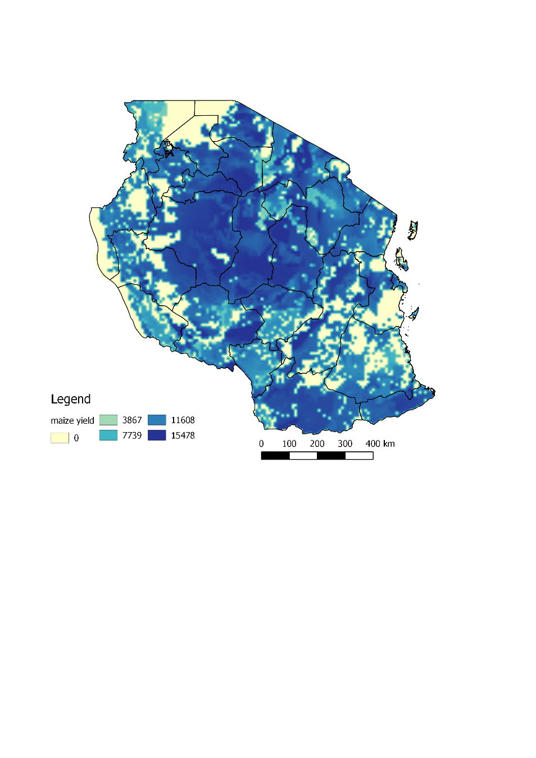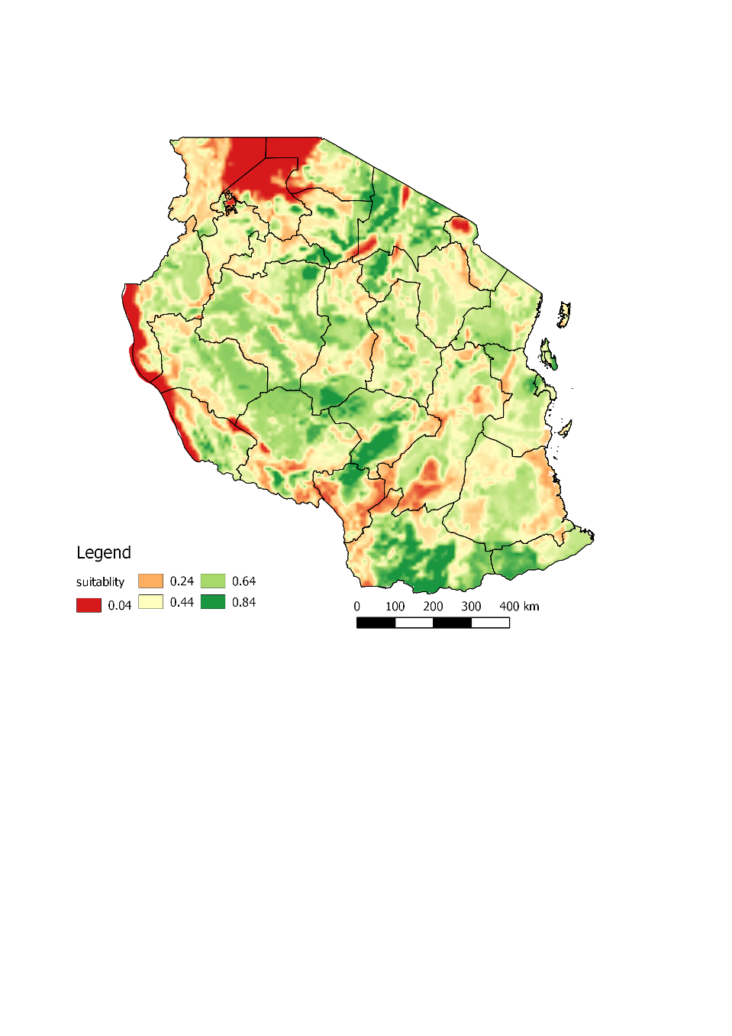

The final land use change layer, i.e., for which the biomass required was equivalent to the amount produced, was retained as the land use change parameter for use as input in MESH.

References for Appendix C

Pfeifer, C., Morris, J., Ensor, J., Ouédraogo-Koné, S., Mulatu, D.W., Wakeyo, M., 2020. Designing sustainable pathways for the livestock sector: the example of Atsbi, Ethiopia and Bama, Burkina Faso. International Journal of Agricultural Sustainability 0, 1–16. <https://doi.org/10.1080/14735903.2020.1824419>.

Pfeifer, C., Morris, J., Ensor, J., Ouédraogo-Koné, S., Mulatu, D.W., Wakeyo, M., 2020. Designing sustainable pathways for the livestock sector: the example of Atsbi, Ethiopia and Bama, Burkina Faso. International Journal of Agricultural Sustainability 0, 1–16. <https://doi.org/10.1080/14735903.2020.1824419>.

**Appendix D – MESH**

The Mapping Ecosystem Services to Human wellbeing (MESH) tool is a modelling platform that integrates Natural Capital Project InVEST ecosystem service models and facilitates scenario analysis. The models in MESH can be used to calculate how ecosystem service supplies are expected to change under alternative land management scenarios. MESH version 0.9 which was used in the referred studies (Appendix A), integrates the InVEST ecosystem service models for Carbon Storage and Sequestration (tonnes/ha/yr), Erosion control (sediment retention, tonnes/yr), Water Provision (M3/yr), Water Quality (avoided nitrogen export, kg/yr), andWater Quality (avoided phosphorus export, kg/yr). Table SI.D.1 presents a short description of each model. The Food Provision (Mg/yr) module was omitted for this study. Additional information on MESH is available at [www.naturalcapitalproject.org/MESH](http://www.naturalcapitalproject.org/MESH).

Table SI.D.1: Model descriptions for components of MESH

|  |  |
| --- | --- |
| **Model** | **Description (from Natural Capital Project website)** |
| Carbon storage and sequestration | The InVEST model uses maps of land use and land cover types and data on wood harvest rates, harvested product degradation rates, and stocks in four carbon pools (aboveground biomass, belowground biomass, soil, dead organic matter) to estimate the amount of carbon currently stored in a landscape or the amount of carbon sequestered over time. Limitations of the model include an oversimplified carbon cycle, an assumed linear change in carbon sequestration over time, and potentially inaccurate discounting rates. |
| Erosion control | The sediment delivery module is a spatially-explicit model working at the spatial resolution of the input DEM raster. For each cell, the model first computes the amount of eroded sediment, then the sediment delivery ratio (SDR), which is the proportion of soil loss actually reaching the catchment outlet. This approach was proposed by Borselli et al. (2008) and has received increasing interest in recent years (Cavalli et al., 2013; López-vicente et al., 2013; Sougnez et al., 2011). See Advantages and limitations for further discussion. The outputs from the sediment model include the sediment load delivered to the stream at an annual time scale, as well as the amount of sediment eroded in the catchment and retained by vegetation and topographic features. |
| Water provision | The model has three components: water yield, water consumption, and hydropower valuation. The first two components use data on average annual precipitation, annual reference evapotranspiration and a correction factor for vegetation type, root restricting layer depth, plant available water content, land use and land cover, root depth, elevation, saturated hydraulic conductivity, and consumptive water use. The biophysical models do not consider surface – ground water interactions or the temporal dimension of water supply. |
| Water Quality | Water purification is an essential service provided by ecosystems. InVEST estimates the contribution of vegetation and soil to purifying water through the removal of nutrient pollutants from runoff. The biophysical model uses data on water yield, land use and land cover, nutrient loading and filtration rates and water quality standards (if they exist) to determine nutrient retention capacity for current and future land use scenarios. It does not address chemical or biological interactions besides filtration by terrestrial vegetation (such as in-stream processes) and is less relevant to locations with extensive tile drainage or ditching, strong surface water-ground water interactions, or hydrology dominated by infiltration excess (dry regions with flashy rains). |

Ecosystem services from agricultural land are often assessed assuming a single cropping system or management practice is applied everywhere and without accounting for agricultural biodiversity on-farm, such as hedgerows, cover crops, intercropping, crop rotations and agroforestry. In reality, crops in smallholder farming systems often grow alongside trees and are inter-mixed with other crops in many configurations which lead to a set of diverse outcomes for a wide range of ecosystem services beyond food, such as wildlife connectivity, firewood, forage, pollination. A meta-analysis was conducted to document the evidence of how selected agrobiodiversity scenarios, specifically agroforestry, intercropping with legumes, and use of cover crops, contribute to erosion control and nutrient (N and P) retention ecosystem services as compared to monocropped systems. The goal of the analysis was to be able to use MESH to model the effect of contrasting agricultural biodiversity scenarios on diverse ecosystem services.

Meta-analysis methodology[2]

Online databases used were Web of Knowledge and Google Scholar. The search (presented in Table SI.D.2) was limited to journal articles (excluded reports, conference papers, ….). No date restrictions were applied.

Table SI.D.2: Keywords in literature search to assess how agrobiodiversity scenarios contribute to ecosystem services

|  |  |  |  |  |
| --- | --- | --- | --- | --- |
| **Agricultural practice** | **Keyword** | **AND** | **AND** | |
| **Climate** | **Nutrient retention** | **Erosion control** |
| Agroforestry | “Agroforest*” | “Tropical” | (“Phosphorus” OR “Nitrogen” OR “nutrient”)  AND  (“retention” OR “export” OR “runoff” OR “leaching” OR “nutrient loss” or biofiltration) | (“Sediment” OR “soil”)  AND  (“erosion” OR “loss” OR ”USLE” or “RUSLE”) |
| Cover crops | “Cover crop*”  “Covercrop*” |
| Intercropping with legumes | “Legume” AND (“intercropping” OR  “mixed crop*”) |

Article filtering: We manually filtered out articles that were not based on empirical studies of the effect of the selected agricultural practice on the ecosystem service of interest, based on the Title and Abstract. Duplicate articles were removed. A record was kept of the number of articles excluded and included. Articles meeting the inclusion criteria were downloaded in pdf format. We also included results from a meta-analysis that recorded the difference in retention efficiencies in tropical agroforestry systems compared to control, conducted in 2014 (Natalia Estrada-Carmona, unpublished).

Database format: We used many of the same columns as used in the InVEST reference databases to organise the data extracted from each article, to ensure compatibility with the MESH modelling environment. Columns mirrored in our database include:

* ID
* LULC_MODIS
* Other LULC details
* Specific LULC
* Continent
* Country
* State/Province
* Specific Location
* Köppen Climate
* Assumed Köppen Climate
* Elevation
* Slope
* Soil type
* + All columns related to nutrient retention
* + All columns related to sediment control
* Original source
* Modelled data

In addition, we recorded the following characteristics of the cropping system where these were provided:

* ABD system:
* **Agroforestry** (crops are planted in amongst trees)
* **Cover crops** (when nitrogen rich crops are planted after harvesting an annual crop, so that the ground stays always covered and soil nutrients are replenished, OR when these same types of crops are planted in among food or fodder crops to keep the soil rich and prevent erosion)
* **Intercropping** (when more than one crop is planted in the same field, usually in alternate rows)
* **Crop rotation** (when annual crops are rotated between seasons)
* **Monocrop** (when only one crop species is grown at any one time on the field)
* Certification: none, organic
* Grazing intensity*: (average animal unit per ha)
* Crop life cycle: Perennial, Annual, Mixed annual-perennial
* Crop richness (count of distinct species)
* Leaf area index (proxy for crop diversity)
* Crop irrigation: Irrigated, Rainfed (including simulated rainfed in experiments)
* Soil management: No till, Tilled
* Soil cover (%)
* Canopy cover (%) (proxy for stem density)
* Latitude
* Longitude
* sedret_compared_to_control** (soil loss)

*only in Nutrient Retention Database

**only in the Erosion Control Database

Results of the meta-analysis are presented in Table SI.D.3 and Table S.D.4. While many studies considered monocropped systems, fewer studies focused on agrobiodiverse systems. Results for sediment retention efficiencies in monoculture, cover cropped and agroforestry fields can be used to obtain mean values along these gradients of agrobiodiversity. These results indicated sediment efficiencies are up to 75% higher on these agro-biodiverse cropping scenarios compared to monocropped systems. There was insufficient information to obtain mean sediment retention efficiencies for intercropped fields.

For nutrient retention, we were able to calculate mean nitrogen retention efficiencies for monocropped, intercropped and crops in rotation, and this showed up to 23% lower retention efficiencies in agrobiodiverse systems compared to monocrops.

These results informed parameterization of the MESH models. The results for sediment retention efficiencies were used for calibration of the MESH sediment model. However, there was insufficient data to calculate mean agroforestry nitrogen retention rates or phosphorus retention rates (n=1). In general, nutrient retention efficiencies and nitrogen and phosphorus loads were of questionable reliability (we would expect lower loads on agrobiodiverse systems) and not used in the MESH nutrient model runs. This is likely because the loads are dependent on fertiliser management practices and therefore the values need to be controlled for farming intensity; which will be done in a future data cleaning step.

Table SI.D.3: Erosion control under different agro-biodiversity scenarios

|  |  |  |  |  |
| --- | --- | --- | --- | --- |
| **ABD system** | **Data available (n)** | **Sediment retention efficiency (%)** | **Mean C factor** | **Mean P factor** |
| Agroforestry | 5 | 61.1 | No data | No data |
| Agroforestry & hedgerow | 5 | 70.8 | No data | No data |
| Agroforestry & mulch | 3 | 99.0 | No data | No data |
| Agroforestry & mulch & cover crops | 1 | 99.0 | No data | No data |
| Cover crops | 5 | 99.0 | No data | No data |
| intercropping | 1 | No data | 0.3 | No data |
| Monocrop | 6 | 25.0 | 0.3 | No data |
| **Total** | **26** |  |  |  |

Table SI.D.4: Nutrient retention under different agro-biodiversity scenarios

|  |  |  |  |  |  |
| --- | --- | --- | --- | --- | --- |
| **Agro-Biodiversity system** | **Data available (n)** | **N efficiency %** | **P efficiency %** | **N load** | **P load** |
| Agroforestry | 1 | No data | 53.9 | No data | No data |
| Crop rotation | 5 | 48.5 | No data | No data | No data |
| Intercropping | 8 | 65.0 | No data | 18.0 | 0.5 |
| Cover crops | 0 | No data | No data | No data | No data |
| Monocrop | 37 | 71.8 | No data | 8.00 | 1.0 |
| Total | 54 |  |  |  |  |

The input data used in MESH are presented in Table SI.D.5 while model parameters are shown in Table SI.D.6.

Table SI.D.5: Input data in MESH

|  |  |  |  |  |
| --- | --- | --- | --- | --- |
| **Variable** | **Data source** | **Resolution** | **Link** | **Citation** |
| Root restricting layer depth (mm) | Harmonized World Soil Database (HWSD) v1.2 soil depth used as a proxy | ~1 km | <http://www.fao.org/soils-portal/soil-survey/soil-maps-and-databases/harmonized-world-soil-database-v12/en/> | Fischer et al., 2008 |
| Land use and cover (LULC) | Baseline: ESA LULC from 2015  Scenarios: six projections of modified ESA LULC generated in the CLEANED model, by ILRI | 300 m | <http://maps.elie.ucl.ac.be/CCI/viewer/index.html> | ESA Climate Change Initiative -Land Cover Project |
| Annual potential evapotranspiration (mm) | Calculated using the Thornthwaite (1948) method and IFRPI 2016-2045 projected mean monthly temperatures. Raw data from World Clim V1.4, processed to create the FutureClim datasets by CCAFS as described in Jones et al. 2009. FutureClim data processed by Ricky Robertson (IFPRI) using MarkSIM V2 to get 2016-2045 climate means (under IPCC RCP6 scenario) for this project. | ~1 km | <http://www.ccafs-climate.org/> | (Thornthwaite, 1948); (Jones et al., 2009) |
| Plant available water content (PAWC, fraction from 0 to 1) | Harmonized World Soil Database (HWSD) v1.2 data on soil available water content (mm/m). | ~1 km | <http://www.fao.org/soils-portal/soil-survey/soil-maps-and-databases/harmonized-world-soil-database-v12/en/> | Fischer et al., 2008;  Calculation for PAWC from (Natural Capital Project, 2018)  InVEST water yield model documentation Appendix A. |

Table SI.D.5: Contd.

|  |  |  |  |  |
| --- | --- | --- | --- | --- |
| **Variable** | **Data source** | **Resolution** | **Link** | **Citation** |
| Mean annual precipitation (mm) | IFRPI 2016-2045 projected mean monthly precipitation. Raw data from World Clim V1.4, processed to create the FutureClim datasets by CCAFS as described in Jones et al. 2009. FutureClim data processed by Ricky Robertson (IFPRI) using MarkSIM V2 to get 2016-2045 climate means (under IPCC RCP6 scenario) for this project. | ~1 km | <http://www.ccafs-climate.org/> | Jones et al., 2009 |
| Elevation (m) | Global USGS/NASA Shuttle Radar Topographic Mission (SRTM) data, provided by CGIAR Big Data (version 4.1) | ~90 m | <https://cgiarcsi.community/data/srtm-90m-digital-elevation-database-v4-1/> | Jarvis et al., 2008 |
| Rainfall erosivity index (R, in MJ⋅mm⋅(ha⋅h⋅yr)−1.) | Rainfall capacity to erode soil. Global Rainfall Erosivity from the European Soil Data Centre (ESDAC) | ~1 km | <https://esdac.jrc.ec.europa.eu/> | Panagos et al., 2017 |
| Soil erodibility (ton⋅ha⋅h⋅(ha⋅MJ⋅mm)−1) | This is a measure of susceptibility of soil particles to detachment and transport. Calculated from HWSD topsoil organic carbon and soil texture data, using OMAFRA (2015) guidelines | ~ 1 km | <http://www.fao.org/soils-portal/soil-survey/soil-maps-and-databases/harmonized-world-soil-database-v12/en/> | Fischer et al., 2008;  OMAFRA, 2015 |
| Catchment boundaries | Hydrosheds level 5 and 6 | NA | <https://www.hydrosheds.org/> | Lehner & Grill, 2013 |
| Country boundary | Global Administrative Unit Layers (GAUL) for 2015 | NA | <http://www.fao.org/geonetwork/srv/en/metadata.show%3Fid=12691> |  |

Source: Authors’ compilation

Table SI.D.6: Model parameters in MESH

|  |  |  |
| --- | --- | --- |
| **Parameter** | **Assigned values** | **Information source** |
| Water yield model-wide parameters | Z parameter (precipitation seasonality): Calculated using *Z* = ((*ω*−1.25)\**Mean annual precipitation*) */ Mean plant available water content, where ω is a parameter characterising natural climatic-soil properties.*  For this study, Z = ((2.7-1.25)*971.241)/105.561 = 13.3 | (Xu et al., 2013) (for *ω* value, approximated) |
| Biophysical table (water yield, sediment and nutrient models) | New monocropped class, new agroforestry class:   * Kc: 0.6,0.8 * Root depth (mm): 2,10 * C factor: 0.45,0.18 * P factor: 0.75,0.5 * Nitrogen load: 11, 5.3 * Nitrogen retention efficiency: 0.25, 0.25 * Subsurface nitrogen load: 1.1,0.53 * Subsurface nitrogen proportion: 0.5,0.25 * Phosphorus load: 3,1.5 * Phosphorus retention efficiency: 0.25,0.25 * Subsurface phosphorus load: 0.3,0.15 | Mean values for C and P factors extracted from OMAFRA (2015). For other parameters, InVEST default parameter values used and modified to fit ESA LULC, i.e. Kc values amended for irrigated cropland (Kc = 0.8) and sparsely vegetated areas (Kc = 0.5). |
| Carbon pools | New monocropped class, new agroforestry class:   * Above ground carbon (t/ha): 2,47 * Below ground carbon (t/ha): 1,7 * Soil organic carbon (t/ha): 52,52 * Dead matter carbon (t/ha): 0.1,1 | Above and below ground carbon estimated based on above-ground values and root-shoot ratios in Table 4.4. & 4.7 & 5.9 of the IPCC (2006) report, and Gaston et al. (1998); soil carbon based on values in Table 2.3 of IPCC (2006); dead matter carbon from Table 2.2 of IPCC (2006). In FAO (Bailey’s) global map of ecoregions, Tanzania is classified as mainly humid tropical (savanna, with some dry tropical/subtropical (steppe). Values for the tropical category are used as this region is where agricultural production dominates. |
| Water demand | New monocropped class: 1100 m3/ha  New agroforestry class: 1300 m3/ha  Existing cropland classes: 1100 m3/ha  Mosaic cropland/natural vegetation: 900 m3/ha  Urban areas: 600 m3/ha  Other classes: 0 m3/ha | InVEST baseline (default) parameter values modified to include new classes, modified to fit ESA LULC. |

Source: Authors’ compilation

Model outcomes for the macroeconomic scenarios from IMPACT (Appendix B) for which land use impacts were simulated in CLEANED-R (Appendix C), thus informed computation using MESH, of the agro-biodiversity effects associated with land use change. Figure SI.D.1 illustrates the distribution of ecosystem services across Tanzania, for the baseline scenario.

Figure SI.D.1: Map of Tanzania and baseline carbon, water yield, phosphorus export, nitrogen export and sediment retention conditions in MESH.

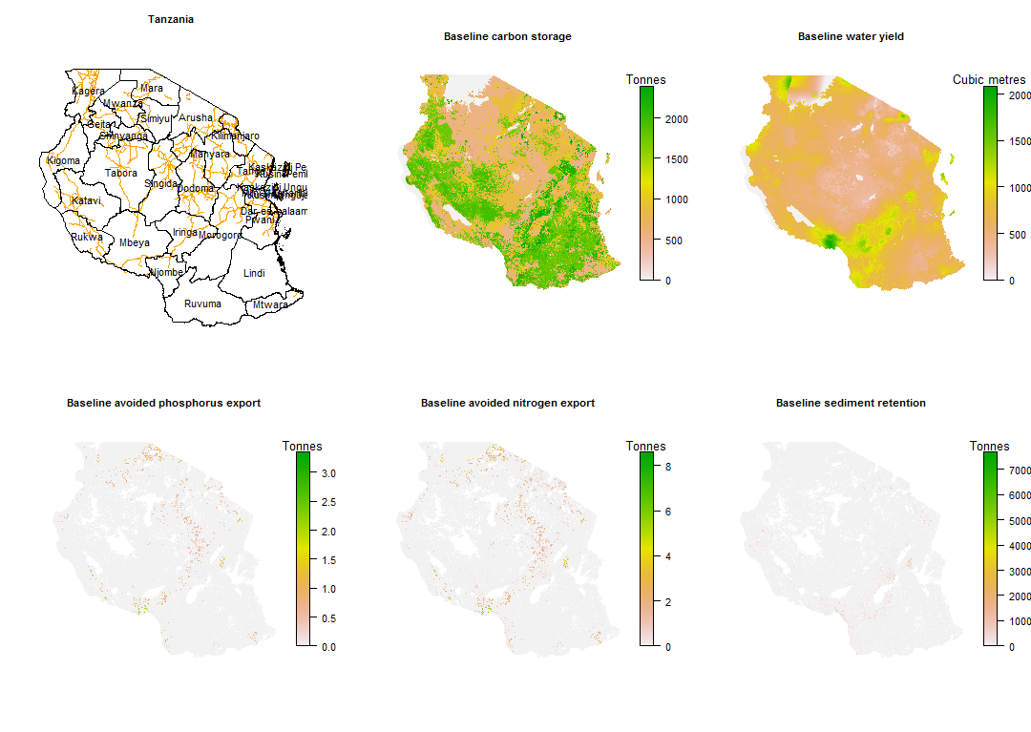

References for Appendix D

Fischer, G., F. Nachtergaele, S. Prieler, H.T. van Velthuizen, L. Verelst, D. W. (2008). Global Agro-ecological Zones Assessment for Agriculture (GAEZ 2008). *IIASA, Laxenburg, Austria and FAO, Rome, Italy*.

Fischer, G., Shah, M., Tubiello, F. N., & van Velhuizen, H. (2005). Socio-economic and Climate Change Impacts on Agriculture: An Integrated Assessment. *Philosophical Transactions of the Royal Society B 360:2067–2083. Http://Rstb.Royalsocietypublishing.Org/Content/360/1463/2067.Full.*

Jarvis, A., H.I. Reuter, A. Nelson, E. G. (2008). Hole-filled SRTM for the globe Version 4. *Available from the CGIAR-CSI SRTM 90m Database (Http://Srtm.Csi.Cgiar.Org).Rome, Italy*.

Jones, Peter G., Philip K. Thornton, and J. H. (2009). Generating characteristic daily weather data using downscaled climate model data from the IPCC Fourth Assessment. Project report. *Available at Http://Www.Ccafs-Climate.Org/Downloads/Docs/Generating_Characteristic_Daily_Weather_Data_using_Downscaled_Climate_Model_Data_Jones_Thornton_Heinke_2009.Pdf, Accessed 08/10/2018*.

Jones, S.K., Wood, S.L.R., Johnson, J.A., DeClerck, F. A. J. (2017). MESH_SDG V1.0. *Https://Github.Com/Skatejones/MESH_SDG (Accessed 08/10/2018).*

NaturalCapitalProject. (2018). Water Yield: Reservoir Hydropower Production. InVEST Model Documentation. *Http://Data.Naturalcapitalproject.Org/Nightly-Build/Release_default/Release_default/Documentation/Reservoirhydropowerproduction.Html (Accessed 06/10/2018)*.

OMAFRA. (2015). Universal Soil Loss Equation (USLE) Factsheet. *Http://Www.Omafra.Gov.on.ca/English/Engineer/Facts/12-051.Htm (Accessed 06/10/2018)*.

Panagos P., Borrelli P., Meusburger K., Yu B., Klik A., Lim K.J., Yang J.E, Ni J., Miao C., Chattopadhyay N., Sadeghi S.H., Hazbavi Z., Zabihi M., Larionov G.A., Krasnov S.F., Garobets A., Levi Y., Erpul G., Birkel C., Hoyos N., Naipal V., Oliveira P.T.S., B. C. (2017). Global rainfall erosivity assessment based on high-temporal resolution rainfall records. *Scientific Reports*, *7*, 4175.

Thornthwaite, C. W. (1948a). An approach toward a rational classification of climate. *Geographical Review*, *38*(1), 55–94.

Thornthwaite, C. W. (1948b). An approach toward a rational classification of climate. *Geogr. Rev*, *38*, 55–94.

Wood, S.L.R., Jones, S.K., Johnson, J.A., Brauman, K.A., Chaplin-Kramer, R., Fremier, A., Girvetz, E., Gordon, L.J., Kappel, C. V., Mandle, L., Mulligan, M., O’Farrell, P., Smith, W.K., Willemen, L., Zhang, W., DeClerck, F. A. (2018). Distilling the role of ecosystem services in the Sustainable Development Goals. *Ecosystem Services*, *29*, 70–82.

1. Citations to be updated on final publications of the associated papers.
2. In addition to authors, Francesco Tacconi contributed to this review.